BECS 22451
Experiment No. 09

INTRODUCTION TO MATLAB SIMULINK

Student Name: G.P.D Thamara
Student Number: EC/2021/005
Date Performed: 09/12/2024
Date of Submission:10/12/2024

Date: 09/12/2024
Experiment No: 09
Experiment Name: INTRODUCTION TO MATLAB SIMULINK

APPARATUS
- A PC or Laptop with MATLAB Simulink installed.

THEORY AND DIAGRAMS
Simulink is a graphical programming environment in MATLAB that extends the capabilities of MATLAB for modelling, simulating, and analyzing multi-domain dynamical systems. It is widely used in various engineering disciplines for its intuitive and visual approach to system design.
- Simulink is an extension to MATLAB.
- In Simulink, users construct block diagram models for dynamic systems, departing from traditional text-based coding.
- Simulink excels in modelling complex nonlinear systems with ease.
- It has the capability to model both continuous and discrete-time components, enhancing versatility in system representation and analysis.

PROCEDURE
Part 01
- MATLAB was started, and Simulink was opened by clicking on the “Start Simulink” button. Alternatively, Simulink could have been started by running the command “simulink” in the command window.
- In the simulation start window, “Blank Model” was clicked, creating a blank Simulink model.
- The Simulink project was saved as “part_01_A.slx” in a folder named “EC_20XX_XXX.” A Word file was created and renamed with the student number, and it was saved in the same folder.
- The “Library Browser” button was clicked to open the Simulink Library Browser, which contained all the Simulink components available for models. In the left panel, “Sources” was selected to open the Simulink Source Models, and “Sine Wave” was selected. The model was dragged and dropped to the canvas. The amplitude was set to “1,” although the default value for amplitude was already 1. The model could have been double-clicked to change this value anytime.
- Components were added by double-clicking on the canvas. The canvas was double-clicked, and “scope” was input to add an output visualizer for viewing the signal generated by the source. “Number of ports” was entered as 1, which could have been changed later from the menu.
- The source and scope were connected by clicking on the terminal ends.
- The simulation was run, keeping everything at default, by clicking the “play” button in the top options bar. The scope was double-clicked to view the output waveform.
- The cursor measurement was clicked, and using the horizontal cursors, the value of the peak-to-peak amplitude was noted. Using the vertical cursors, the periodic time of the waveform was noted.
- A screenshot of the circuit diagram and waveform was taken and inserted into the created Word file under Part 01-A. The Word file was updated with the amplitude and frequency of the waveform that had been measured.
- A “gain” block was inserted between the source and scope, and the gain was changed to “3.”
- The “number of ports” of the scope was changed by double-clicking the scope and navigating to file >> number of input ports >> 2. The second input of the scope was used to observe the input waveform by directly connecting it to the source.
- The simulation was run, and the output waveform was observed. Cursor measurements were used to measure the parameters of both waveforms as had been done in step (8).
- The results were recorded in the Word file under Part 01-B as had been done in step (9)

Part 02
- A new project was created in Simulink by navigating to File >> New >> Blank Model, and the circuit shown in Figure 6 was designed.
- Blocks for the circuit were inserted from Simscape >> Specialized Power Systems >> Fundamental Blocks on the left-side panel. An AC Voltage Source from Electrical Sources was used as the power source for the system, and the VRMS value was set to 230V. Diodes were inserted from Power Electronics, and the tick for “Show measurement port” was removed to eliminate additional ports, if needed. Current and voltage sources were added from Measurements, and a scope was inserted to observe the three outputs.
- The same procedure was followed, and the circuit shown in Figure 6 was constructed.
- The Power gui block was inserted, and the simulation type was set to Discrete.
- The simulation was run with a 0.05 s stop time, and the three outputs were observed. Step 13 was repeated, and the content was saved under Part 02-A.
- A capacitor with a capacitance of 0.01 µF was inserted in parallel with the load resistor, and the change in waveforms was observed. Step (d) was repeated, and the content was saved under Part 02-B.
- The capacitance was changed to 0.1 µF, and the change in waveforms was observed. Step (d) was repeated, and the content was saved under Part 02-C.

OBSERVATIONS
Part 01
A. Amplitude (peak to peak) = 2
Periodic time = 159.153 mHz
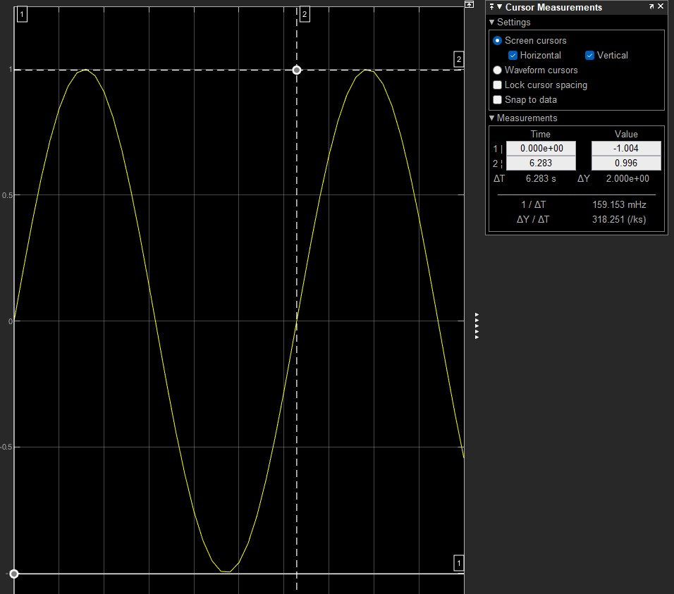

B. Amplitude (peak to peak) = 6
Periodic time = 159.153mHz
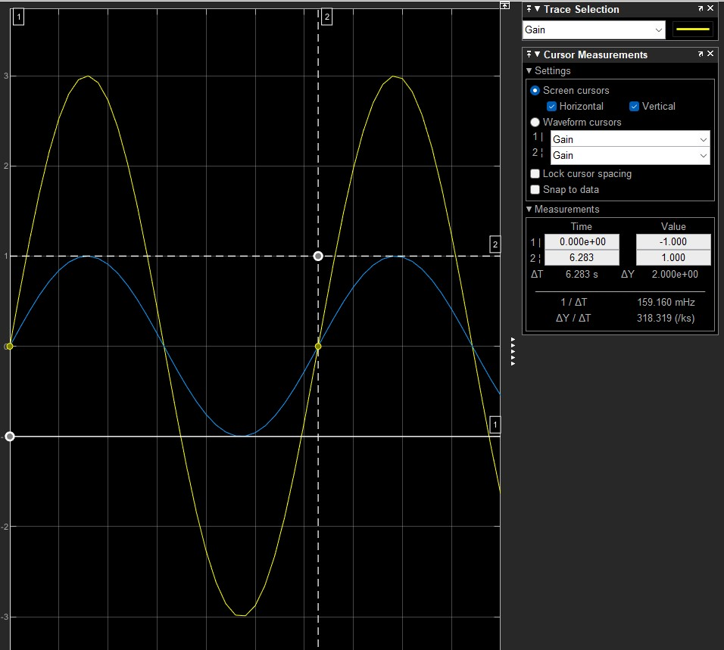

Part 02

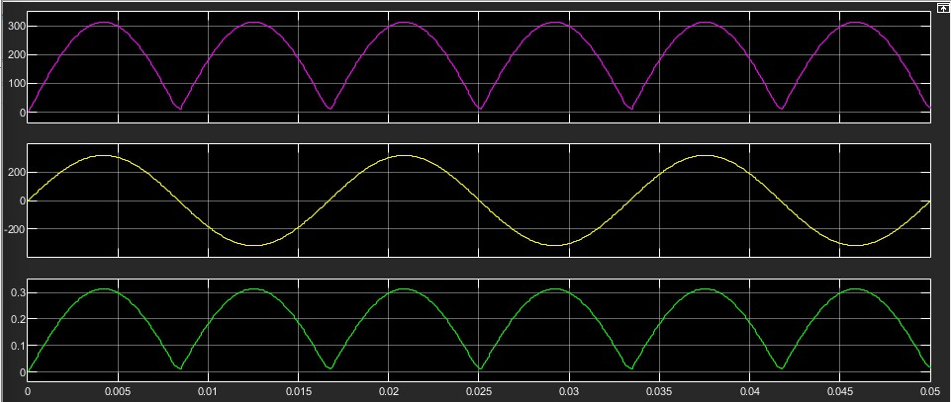
A.

B.
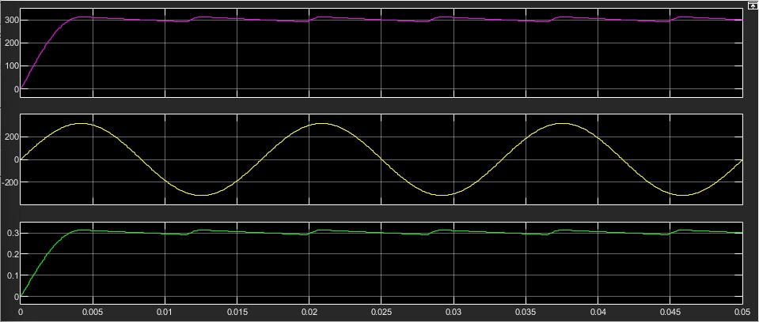

C.
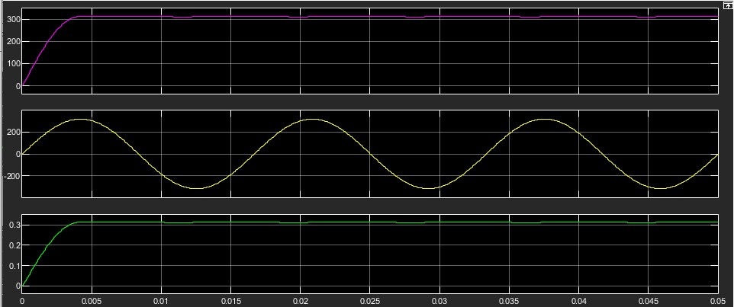

DISCUSSION
Simulink is a graphical computer programming environment where systems are depicted by interconnected blocks, which perform several mathematical and physical tasks. The blocks are specific types of functions to do some mathematics or logic, signal processing or other work and these blocks are connected to show the flow of data. This method is beneficial in system design and analysis since it enables the engineer to graphically build systems and then simulate them and in the long run be able to grasp the relationships between different aspects of the system. Because of the modularity of this tool, it is easy to divide the system into sub-systems thus making it easier to debug as well as helping the user to make iteration on the design with real time changes and tweaking of the system’s characteristics. Simulink is used in almost all engineering disciplines including electrical engineering, mechanical engineering, aerospace engineering and control systems engineering where they use it in applications such as designing power electronics, modelling flight dynamics, and simulating dynamics of complex systems including robotic arms or vehicle suspensions. The benefits include simplicity of modeling allowing engineers to explore system response to different inputs without actual hardware, integration with MATLAB for analysis and scripting. Real-time testing is also possible with hardware-in-the-loop functionality implemented in Simulink, a broad set of libraries for utilizing minimal custom codes and mimics, and scalability to model both simple and complex multi-domain systems. Such characteristics make Simulink to be a comprehensive tool for designing, simulating and analyzing systems as well as enhancing the innovation and efficiency of the engineering processes.

